

**Rajshahi University of Engineering & Technology**

**Lab Report on   
Industrial Electronics Sessional  
ECE 3206**

**Submitted by**

**Deba Priyo Guha**

**Roll: 1810027**

**Department of Electrical & Computer Engineering**

**Rajshahi University of Engineering & Technology**

**Submitted to**

**Hafsa Binte Kibria**

**Lecturer**

**Department of Electrical & Computer Engineering**

**Rajshahi University of Engineering & Technology**

**Experiment No: 04**

**Experiment Name:** Study of Identifying Signal Delays using Cross Correlation

**Theory:**

The cross-correlation approach is a frequently employed method for figuring out how much time has passed between two signals. When examining the connection between two time-varying signals, such as audio or sensor data, it is very helpful. The process is comparing the two signals' similarity at various time offsets and determining the offset that optimizes the correlation.

We may use the cross-correlation approach to determine the time delay by doing the following steps:

1.Get the two signals for which you wish to calculate the time delay in step They'll be known as Signal A and Signal B.

2. If required, preprocess the signals. Depending on your particular application, you might need to eliminate any unwanted noise or employ relevant filtering techniques.

3. Determine the connection between Signals A and B. The correlation is calculated at each time offset while sliding one of the signals over the other.

4. Find the offset that corresponds to the highest correlation value to find the time delay. The time delay is the amount of time required to shift or delay one signal in order for it to most closely coincide with the other signal.

**Software Used**: MATLAB

**Code:**

|  |
| --- |
| clc;  clear all;  t = **0** : **0.01** : **8**;  rand=randi([-**4**,**4**],**1**,**1**)  x=(**1**)*(t>=**1** & t<=**2**) + ((-**1**)*(t>**2** & t<=**3**)) + ((**2**)*(t>**3** & t<=**4**)) + ((**1**)*(t>**4** & t<=**5**)) + ((-**2**)*(t>**5** & t<=**6**));  y=(**1**)*(t>=**1**+rand & t<=**2**+rand) + ((-**1**)*(t>**2**+rand & t<=**3**+rand)) + ((**2**)*(t>**3**+rand & t<=**4**+rand)) + ((**1**)*(t>**4**+rand & t<=**5**+rand)) + ((-**2**)*(t>**5**+rand & t<=**6**+rand));  subplot(**3**, **1**, **1**);  plot(t, x);  title('**1**st Signal');  subplot(**3**, **1**, **2**);  plot(t, y);  title('**2**nd Signal');  range = length(t) - **1**;  z = (-range : range) / **100**;  cor = xcorr(y, x);  **if**(rand<**0**)  subplot(**3**, **1**, **3**);  plot(z, cor);  title('Advance');  elseif(rand>**0**)  subplot(**3**, **1**, **3**);  plot(z, cor);  title('Delay');  **else**  **subplot**(**3**, **1**, **3**);  plot(z, cor);  title('No Delay');  end |

**Output:**

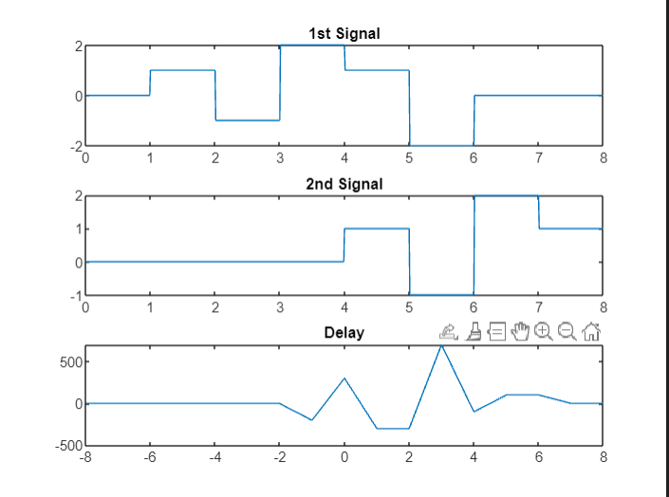

**Fig. 1**: Finding Delay using Cross Correlation

**Discussion & Conclusion**:

In this experiment, we used the cross correlation approach to determine the latency of a discrete signal. Everything we received was just what we expected. Thus the experiment was successful.